
American International University-Bangladesh (AIUB)
Department of Computer Science Faculty of Science & Technology(FST)

Air Ticket Management System

A Software Engineering Project Submitted
By Anik Kumar Saha

Semester-->Spring-25-26 |  | Section: D
SL | Student Name | Student ID
1 | GOLAM MORTAZA | 23-51802-2
2 | SHAMSUL ARIFIN | 24-56780-1
3 | MD. SHAFI MAHMMOD | 23-54122-3
4 | SHADMAN SAKIB | 23-54929-3
5 | MD MEHEDI HASAN ALIF | 23-51539-1

Table of Contents

- Project Proposal................................................................................................................... 03
  - Background to the Problem .................................................................................................03
  - Selection of Process Model ................................................................................................. 03-06
- Software Requirements Specification (SRS) / PRD ......................................................... 07-19
  - Scopes and Features.............................................................................................................19-20
  - User Story Table ....................................................................................................... ………21-29
  - Requirements Traceability Matrix ....................................................................................... 30
    - Functional Requirements .............................................................................................31-32
    - Non-Functional Requirements ......................................................................................32-33
- Software Design ....................................................................................................................... 34
  - System Deisgn ..................................................................................................................35-36
  - UI Deisgn using Figma .....................................................................................................37-40
- Software Testing ......................................................................................................................... 41-48
- Conclusion ................................................................................................................................... 49

1. PROJECT PROPOSAL
1.1: Background to the Problem
With the rapid development of information technology airline passengers have come to expect fast flight search and availability in real time, clear pricing and confirmation on-line, secured online payment, and immediate booking confirmation, but many traditional airline ticket systems still use manual or semi-digital processes that often result in long wait times, customer mistakes in booking and poor customer service. Passengers have also difficulty in comparison to flights, monitoring bookings and learning ticket rules.

In terms of the airline side, a manual system for bookings, payments, cancellations and refunds increases employee workload, overall costs and risk of human error. Lack of centralized system makes it difficult for administrators to maintain control over users, track transactions and generate accurate reports.

To solve this problem Smart Air Ticket Management System is proposed. Smart Air Ticket Management System contains a central digital based platform for Admin, Employee and Passenger. Passengers can find flights, book tickets, pay securely and cancel tickets, while employees are in charge of all details of flights, they also help customers to solve their problems while administrators are in charge of the entire system which can generate reports. Smart Air Ticket Management System increases efficiency, reduces costs and customer satisfaction.

1.2 Selection of Process Model
For Air Ticket Management System we chose Scrum Model. Scrum is an Agile software development methodology, which is done in small steps and especially suitable for systems like Online Booking Portal. AS this is a multi user, real time and changing system, Scrum will give team greater flexibility and efficiency.
In Scrum, the development work is broken down into small increments (called sprints) that usually last between 2 to 4 weeks and build an actual piece of the system (instead of building the entire system at once, the system is implemented in smaller bits).
While at the beginning of the project all requirements are mapped out to a Product Backlog (for this system) and include things like: flight search, flight schedule management, ticket booking, seat checking, online payment, cancellation, refund processing, user management, and generation of report. During Sprint Planning some features are chosen to be added to the Sprint Backlog and team starts working on implementing those features during the sprint.
Each sprint involves design, coding, testing and integration. After the sprint is complete a finished system is presented to get feedback. The team also goes through their work to see what can be done better for the next sprint.
Scrum was chosen because the system has many connected modules, like booking, payment, cancellation and reporting. With Scrum its very easy to develop and test those modules one by one. The system has different User categories like Admin, Employee and Passenger, so regularly getting feedback improves usability and security of the system. Scrum is also very good for academic and team projects, because it can also help to improve teamwork, reduce errors early on and maintain working software. So Scrum Model is a good choice when developing the Smart Air Ticket Management System.

1. Scrum Workflow Visualization
Product Backlog
↓
Sprint Planning
↓
Sprint (2–3 Weeks)
↓
Design → Coding → Testing
↓
Sprint Review
↓
Sprint Retrospective
↓
Increment Release

2. Scrum Phases Applied to the Project

1. Product Backlog
All system requirements such as user authentication, flight management, booking system, seat allocation, payment processing, and refund management were listed and prioritized.

2. Sprint Planning
The backlog was divided into multiple sprints. Each sprint focused on a specific module, such as:
o Sprint 1: Login & User Management o Sprint 2: Flight & Seat Management o Sprint 3: Booking & Payment System

3. Sprint Execution
During each sprint, design, coding, and testing were performed simultaneously using C# and SQL Server.

4. Sprint Review
After each sprint, the developed features were reviewed to ensure they met the functional requirements. 5. Sprint Retrospective

Feedback was analyzed to improve performance, fix issues, and enhance system quality in the next sprint.

6. Incremental Release

At the end of every sprint, a working and testable version of the system was produced.

3. Why Agile (Scrum) Model Was Chosen
The Agile Scrum model was selected for the Airline Management System due to the following reasons:
- Supports changing and evolving requirements
- Allows early detection and fixing of errors
- Suitable for GUI-based and database-driven applications
- Encourages continuous testing and improvement
- Ensures faster delivery of functional modules
- Ideal for team-based academic projects
Using the Agile Scrum model helped the team develop the Airline Management System in a flexible and structured manner, ensuring better quality, improved collaboration, and a more reliable final product.

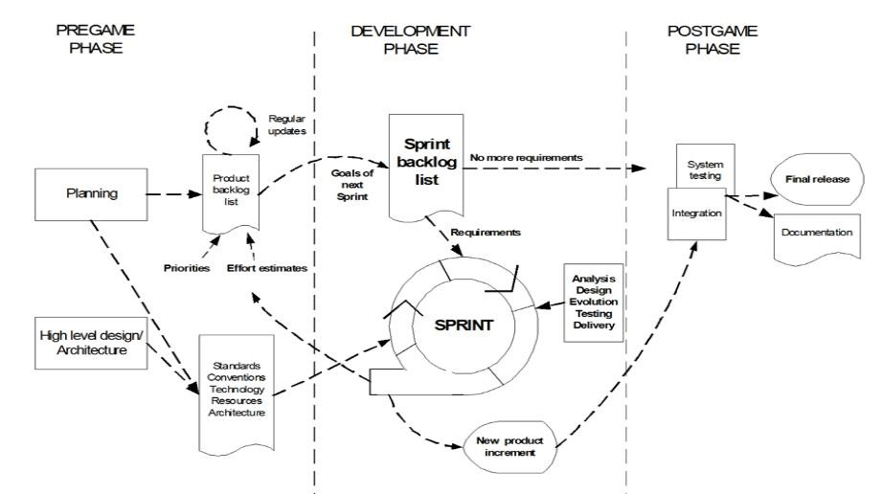
2. SOFTWARE REQUIREMENTS SPECIFICATIONS (SRS) / PRODUCT

REQUIREMENTS DOCUMENT (PRD)-
Template Name | Air Ticket Management System
Goals & Objective | The goal of this project is to develop an efficient, userfriendly, and secure Air Ticket Management System that allows passengers to book tickets, managers to manage flight operations, and admins to oversee the system while ensuring accuracy, reliability, and smooth operations.  From this website user/miner can:  - Allow passengers to search, book, and cancel tickets easily.  - Enable managers to manage flights, schedules, and bookings.  - Allow admins to control users, monitor system, and generate reports.  - Ensure data security, accuracy, and a user-friendly interface
Client Information
Product Type | Web Application
Domain | Web2
Access Layers | Passengers, admin, managers
Design Required | Yes

Phase | No | Specification [Role] | Acceptance Criteria
phase (Auth Feature) | 1 | Signup [admin] [Passengers] [manager] | - Email (input) field should only accept a valid and unregistered email address; otherwise show "Email already used" message.  - Password (input) must not be empty; otherwise show "Please enter a password" message. - Re-password (input) must match the password; otherwise show "Password do not match" message. - User type must be selected (Admin / Manager / Passenger); otherwise show "Please select a user type" message.

 |  |  | - On clicking Signup, credentials will be stored in the database, and the user will be redirected to their dashboard. - A copy of the login information will be sent to the user’s registered email.
phase (Auth Feature) | 1 | Sign in [admin][passengers] [managers] | - Email (input) field must contain a registered email; otherwise show "Email not found" message.  - Password (input) field must not be empty; otherwise show "Please enter password" message.  - If email and password do not match, show "Invalid email or password" message.  - On clicking Sign In, the system will verify credentials and redirect the user to their respective dashboard (Admin / Manager / Passenger).  - Optionally, provide a "Forgot Password" link to recover the password via registered email.
Phase(Auth Feature) | 3 | Forgot Password | User must be able to open the "Forgot  Password" page from the login screen.  User must enter a valid registered email; otherwise the system shows “Email not found”. System must send a password reset link or OTP to the user’s registered email. User must be able to open the reset link/OTP page without errors.

 |  |  | User must enter a new password that meets system rules (e.g., minimum length). User must get a success message after the password is reset. User must be redirected to the login page after successful reset.
phase (Dashboard) | 1 | Menu [Passengers] | Passenger must be able to access the Dashboard and view flight updates, bookings, and notifications.  Passenger must be able to search flights using flight number, date, route, or availability.  Passengers must be able to book flights, with system validation for seat availability and successful booking confirmation.  Passengers must be able to make payments securely and receive confirmation after successful payment. Passenger must be able to request refund, where the system must accept the request and store it as “Pending”.  Passengers must be able to view booking history, including flight details, status, and payment info.  Passenger must be able to update profile information, with system validation and success message after update. Clicking Sign Out must log the passenger out immediately and redirect to the login page.

phase (Dashboard) | 2 | Menu [Admin] | Admin must be able to access the Dashboard. Admin must be able to add, update, and delete flights with proper field validation, confirmation messages, and error handling.  Admin must be able to add, update, and delete bookings, where the system must validate seat availability and show success or error messages.  Admin must be able to add, update, and delete employee accounts, with correct ID validation and confirmation before deletion.  Admin must be able to update and delete Payment records, with system validation and success confirmation. Admin must be able to manage Refund Requests, approve refunds, update status to “Paid”, and store refund transaction details. Admin must be able to generate and view Reports (booking, flight, payment, refund, revenue) with accurate filtered data.  Clicking Sign Out must immediately log the admin out, clear session data, and redirect to the login page.
phase (Dashboard) | 3 | Menu [Employee] | Employee can view all flights and update flight details with field validation and error handling.

Successful flight update must display a confirmation message. Employees can add bookings by entering passenger details, flight info, and seat availability validation.
System generates a booking confirmation number after successful booking.
Employee can search and update bookings; system validates seat availability and shows update confirmation. Employee can delete bookings and payments with system confirmation before deletion.
Employees can update payment status (Pending → Paid) with payment ID validation and success message.
Employee can create refund requests, store them as pending, and process refunds as “Paid” with transaction record.
Clicking Sign Out logs the employee out and redirects to the login page.
Phase(top and bottom button) | 1 | Top bar | Passengers can enter flight number, date, or route.  Field must validate input format (e.g., date in correct format). Clicking performs the search based on the input field.  Clicking it reloads the flight data or resets the search field.

 |  |  | Ensures the latest flight availability is displayed.
Phase(top and bottom button) | 2 | Left Bar | Flight: Must open the flight page and display all available flights instantly. Booking: Must show booking options/history and allow the user to manage bookings smoothly.  Payment: Must open the payment section and show all pending or completed payments clearly.  Refund: Must allow the user to view refund status or submit a refund request successfully. Log Out: Must log the user out immediately and redirect to the login page without errors.
Phase(Flight) | 1 | Flight [admin, managers, passengers] | Admin must be able to add new flights with all required details and get a success message. Admin must be able to update existing flights, and changes must save correctly and able to delete flights .  Employee must be able to view all available flights with details search flights by no origin or date .  Employee must receive updated flight status (delayed, cancelled, full). Employee cannot add, delete flights (view-only). Passenger must be able to view flights including time, origin, destination, and availability.  Passenger must see realtime seat availability. Flight list must refresh properly when user

 |  |  | reloads or searches again.
Phase(Booking Flight) | 1 | Booking[Admin,  Managers ,Passengers] | Admin must be able to view, update, and delete any booking with full details.  Admin can search bookings by passenger name, flight number, or date.  Employee must be able to all bookings and assist in creating bookings for passengers.  Employee can update booking details with proper seat validation. Passenger can book flights with real-time seat availability validation.  Passenger must receive booking confirmation after successful booking. Passenger can view and cancel their own bookings, with status updating correctly. All users must search bookings and see accurate, up-to-date booking information.
Phase(Payment) | 1 | Payment [admin , managers ,passengers) | Admin must be can view all payment records with full details (amount, status, booking ID). Admin must be can update payment status if required (e.g., Verified, Failed).  Employee able to can view passenger payment details to assist with issues or confirmation. Employee can verify if a booking has a completed payment before finalizing it.

Passenger can make payments securely using the available payment method.
Passenger must receive instant confirmation after successful payment.
Passenger can view their payment history, including status and transaction details.

System must validate payment data and update booking/payment status accurately for all users. All users must search bookings and see accurate, up-to-date booking information.
Phase (refund) | 1 | Refund [admin ,Employee , passenger] | Admin must be view all refund requests with full details (reason, amount, status).  Admin can update refund status (Pending, Approved, Rejected) and save changes.  Employee can just view passenger refund requests to assist or provide information. Employee can verify booking and payment details before forwarding refund issues.  Passenger must submit a refund request, and the system must store it as “Pending”.  Passenger must be view their refund status and details at any time.  System must validate refund eligibility before accepting the request.

All users must see accurate, up-to-date refund information after any status change.

System must validate payment data and update booking/payment status accurately for all users. All users must search bookings and see accurate, up-to-date booking information.
Phase (Report ) | 1 | Report (admin) | Admin must be able to access the Reports page from the dashboard. Admin can generate reports for flights, bookings, payments, and refunds.  System must load reports with accurate, up-to-date data. Admin must see summary totals (e.g., total bookings, total payments).  System must generate reports quickly and without crashing. System must validate refund eligibility before accepting the request. All users must see accurate, up-to-date refund information after any status change. System must validate payment data and update booking/payment status accurately for all users.
Phase ( Profile ) | 1 | View | Null value .
Phase ( profile ) | 2 | Edit Profile | User must be able to open the Edit Profile page from the dashboard.
User can update personal details like name, email, phone number, and address. System must validate all inputs (e.g., valid email format, required fields). User must get a success message after updating profile successfully.
Changes must be saved in the system and visible immediately.
Users must be able to cancel editing and return to the dashboard without changes.

2.1 Scopes and Features
1 . Administrator (Admin):
The Admin is the highest authority of the system and controls the entire platform. The admin can:
1.Add, update, and delete flight information.
2.. Manage employee and passenger accounts.
3.Monitor all bookings, payments, cancellations, and refund requests.
4.Generate reports related to flights, revenue, and system usage.
5. Ensure system security, data accuracy, and smooth operation.
The admin plays a vital role in controlling and monitoring the overall system.

2. Employee:
Employees are responsible for the operational activities of the system. They can:
1.Update flight schedules and seat availability.
2.View passenger booking details. - Assist passengers with ticket booking, cancellation, and refund processing.
3.Verify payment status and handle customer support tasks.
The system helps employees work efficiently with less paperwork and fewer errors.

3.Passenger (Customer) :
Passengers are the end users of the system. They can:
1.Search for available flights based on destination, date, and time.
2.Book flight tickets online. - Make secure online payments.
3.Cancel tickets when needed.
4. Submit refund requests and track their status.
This system provides passengers with a fast, user-friendly, and reliable digital ticketing experience.

2.2 User Story Table
User Admin:
As A/An | I Want to | So that | Acceptance Criteria
Admin | Create a new admin profile | I can enroll myself in the system | The new admin profile is created, validated, and immediately usable for login.
Admin | Create e new  employee profile | I can enroll a employee in the system | The new employee is enrolled in the system, visible in the employee list, and issued login access.
Admin | Login with my  username and password | The system can authenticate me & i can trust it. | Successful authentication grants dashboard  access, while failure displays an immediate, specific error.
Admin | View my own profile details | I can see a list that contains information provided in the registration form | All registered profile information is displayed in a read-only view with a clear option to navigate to the edit page.
Admin | Update my information | I can replace the incorrect information with the right  information | The admin can successfully change and save their personal information, followed by a confirmation message reflecting the changes.
Admin | Update  Employee  Information | I also can replace the incorrect employee  information with the right  information | The admin can successfully update any employee's details and an audit trail records the modification.
Admin | View  Customer  List | I can see all my customers information | A comprehensive, searchable, and sortable list of all customer accounts is displayed to the admin.

Admin | Update  Flight  Booking  Information | Everyone is aware of update information | The admin can successfully alter the booking details, and the passenger receives an updated confirmation.
Admin | View  Passenger List | I can see all my passengers list | The system displays a complete and searchable list of all registered passengers.
Admin | Checking payment  System | I can check all payment transaction | The system allows the admin to view and audit all payment transactions successfully.
Admin | Using  Refund  System | I can manage financial discrepancies and process customer reimbursement requests accurately. | The admin can initiate and process a refund request, and the system confirms the transaction  is recorded
Admin | Search  Employee  & Passenger  list | I can quickly find and access the details of any user (employee or  passenger) within the system. | The admin can access a combined or separate search interface to quickly find details of both employees and passengers.
Admin | Search for flight & ticket booking | I can instantly retrieve specific flight information or book records when handling inquiries or issues. | The admin can quickly search and retrieve details for any specific flight or ticket booking using relevant identifiers.
Admin | Sign Out | My session is secured, preventing unauthorized  access to the administrative functions when I leave the desk. | he admin is securely logged out of the system  from all devices and redirected to the login page.

User Employee
AS A /AN | I Want To | So What | Acceptance Criteria
Employee | view all  available flights | I can see all flights to assist passengers | Employee must be view all flights with details; search flights by number, date, or route; flight data loads correctly.
Employee | Manage passenger bookings | I can help passengers with their bookings | Employee able to view bookings, update details, assist in creating bookings; system validates seat availability.
Employee | Verify passenger payments | I can ensure bookings are confirmed | Employee can view payment details, verify payments, see completed and pending payments.
Employee | Assist refund requests | I can process refund issues correctly | Employee must be view refund requests, check eligibility, verify booking/payment info before forwarding.
Employee | Update my profile | My info stays accurate and updated | Employee can edit personal info; system validates input; success message displayed after update.
Employee | Reset my password | I can regain access if I forget  it | Employee can request reset via registered email; system sends OTP/link; new password validated and updated.
Employee | Access dashboard features | I can perform my daily tasks | Employee able to access flights, bookings, payments, refunds; sidebar navigation works; pages load correctly.

User Passengers:
As A/An | I want to | So that | Acceptance Criteria
Passenger | Search destination | I can travel | Will show different destination
Passenger | Search date by destination | I can travel in margin time | Will show available seat
Passenger | Book a ticket | I can book a ticket to confirm the seat | It will show the payment option
Passenger | Can payment | I can confirm ticket | Seat confirmed
Passenger | Can cancel the ticket | I can cancel ticket | Request for refund
Passenger | Request for refund | I can get back money | Refund request accepted
Passenger | Can sign out | I can close the chat | Will sign out

User Payment:
As A/An | I Want To | So That | Acceptance Criteria
Admin | View all payment records | I can audit all transactions | All payments shown with amount, status, and booking ID
Admin | Update payment status | I can correct payment errors | Payment status updated successfully with confirmation message
Employee | View passenger payment details | I can assist with payment issues | Payment details displayed clearly with pending and completed status
Employee | Verify payment before booking | I can confirm booking is paid | System validates payment and shows confirmation
Passenger | Make online payment | I can confirm my ticket | Payment processed securely and booking confirmed
Passenger | View payment history | I can track my transactions | All payments shown with date, amount, and status

User Refund:
As A/An | I Want To | So That | Acceptance Criteria
Admin | View all refund requests | I can manage reimbursements | All refunds shown with reason, amount, and status
Admin | Update refund status | I can approve or reject refunds | Status updated to Approved/Rejected with confirmation
Employee | View passenger refund requests | I can assist with refund issues | Refund requests displayed with booking and payment details
Employee | Verify refund eligibility | I can forward valid requests | System checks eligibility before processing refund
Passenger | Submit refund request | I can get my money back | Refund request stored as Pending successfully
Passenger | View refund status | I can track my refund progress | Status shown as Pending, Approved, or Paid

User Story Board using Trello :
The user story board in Trello organizes tasks into Product Backlog, To Do, In Progress, and Done. It provides visibility of ongoing work, responsibilities, and progress for the Air Ticket Management project
Admin :
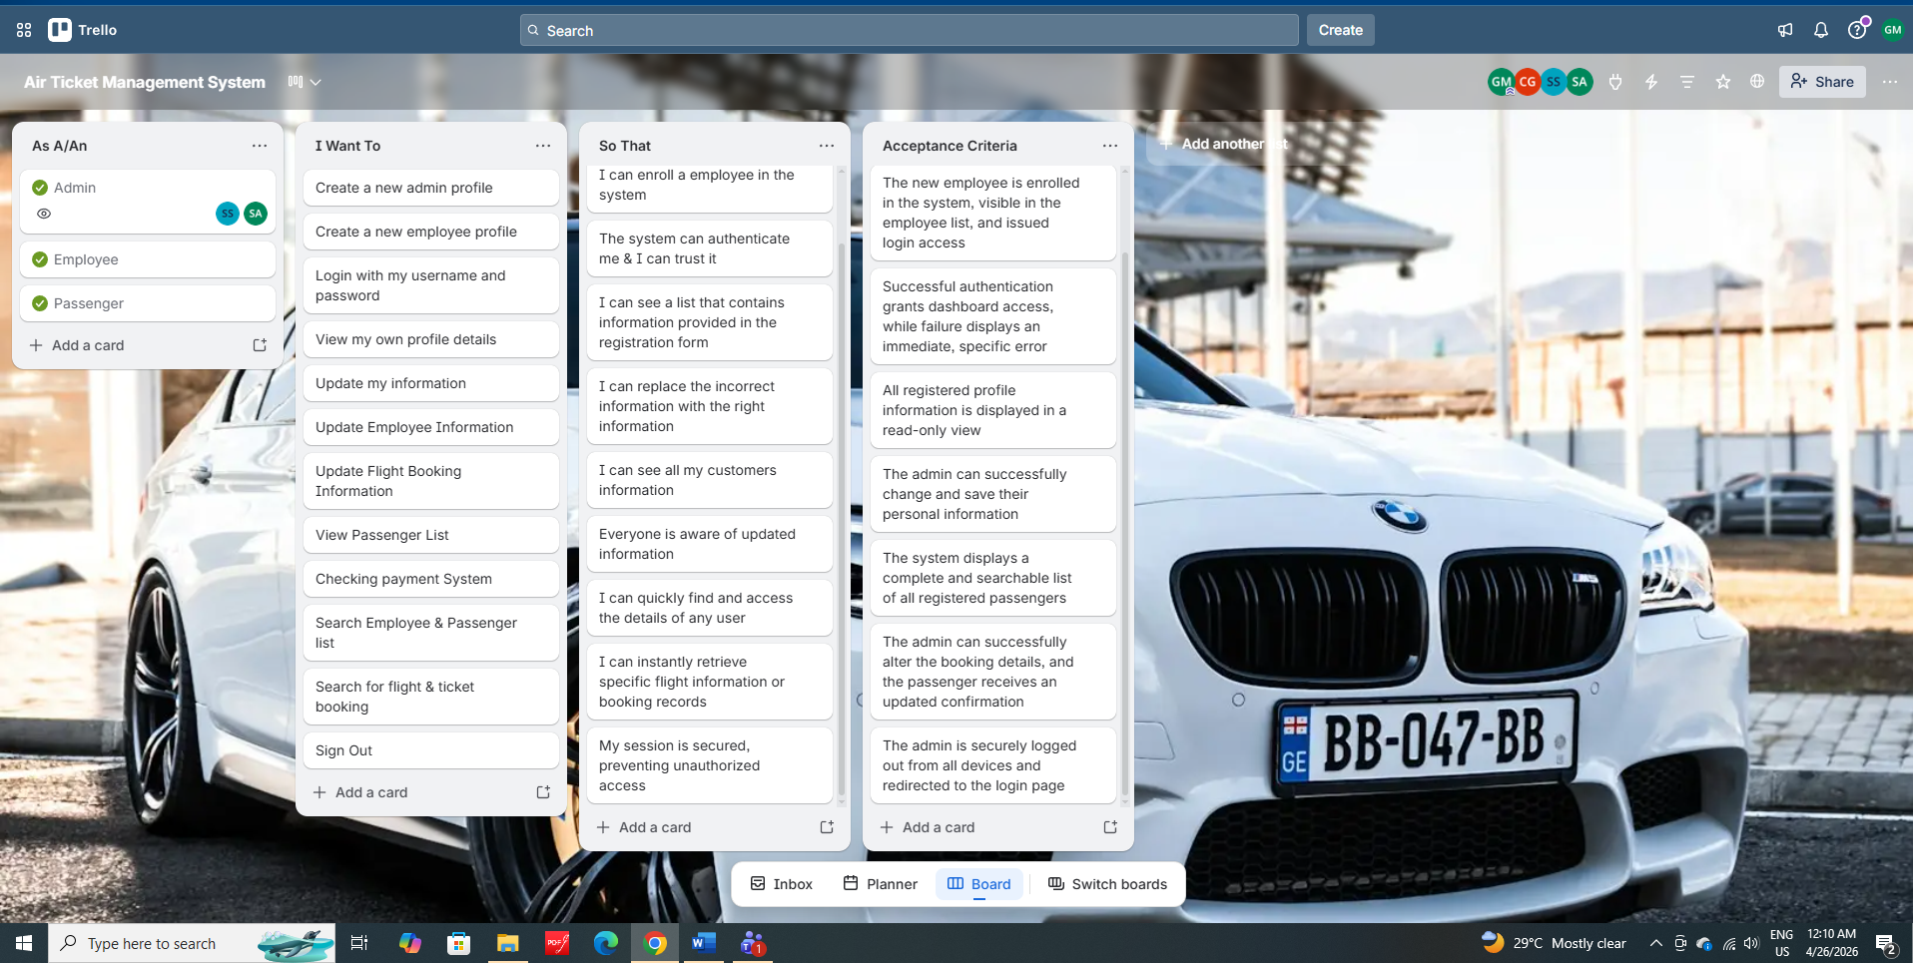

Employee:
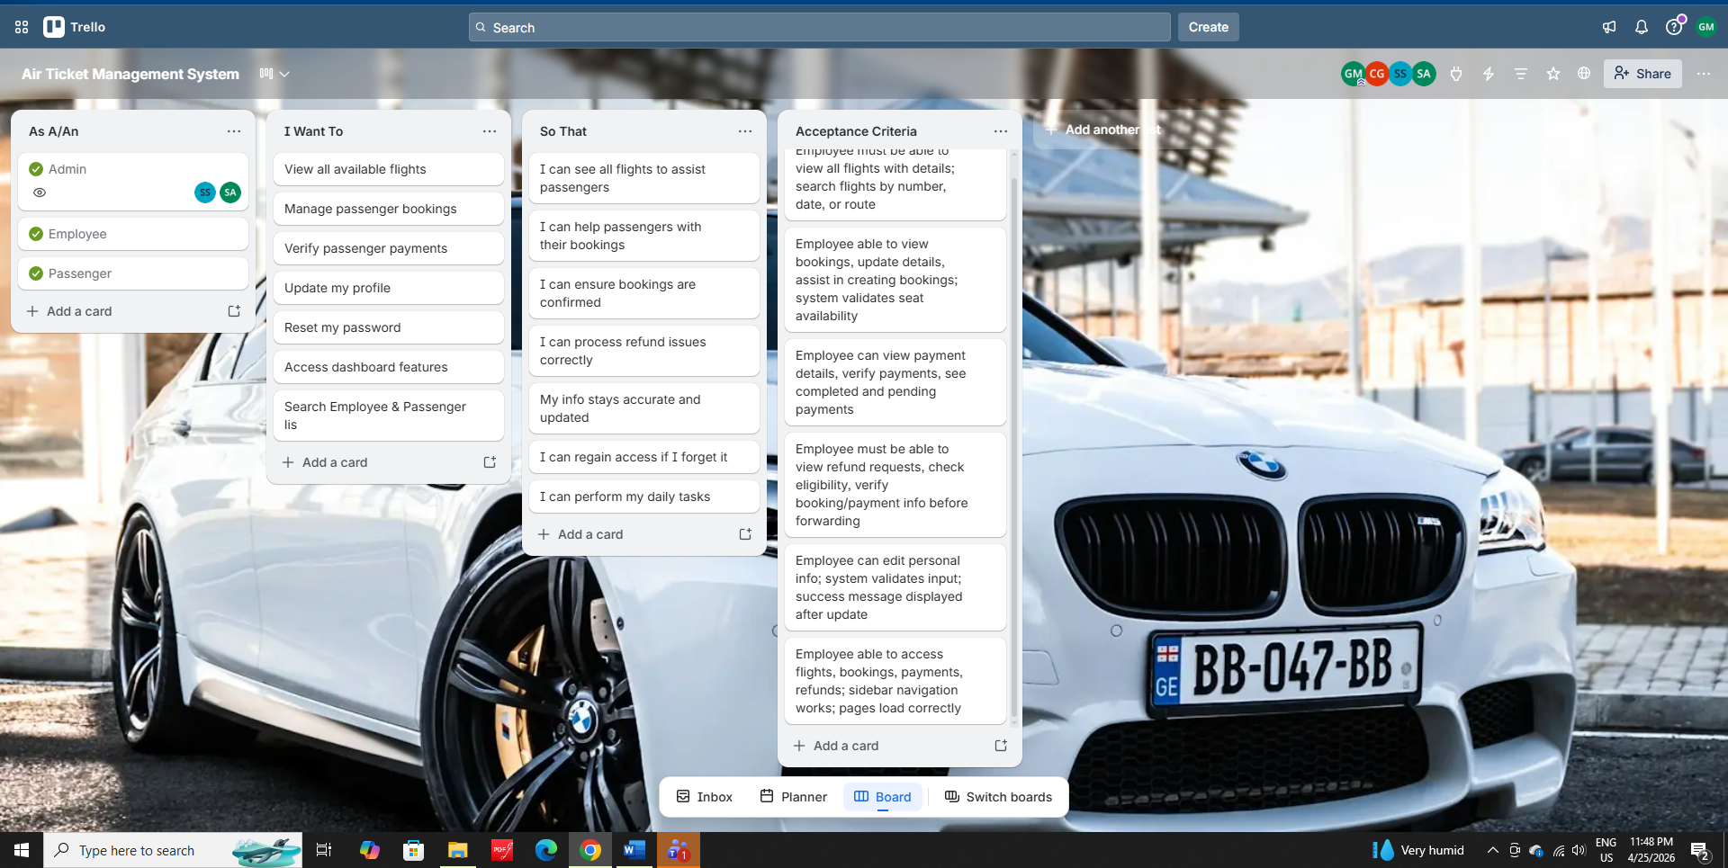

Passenger :
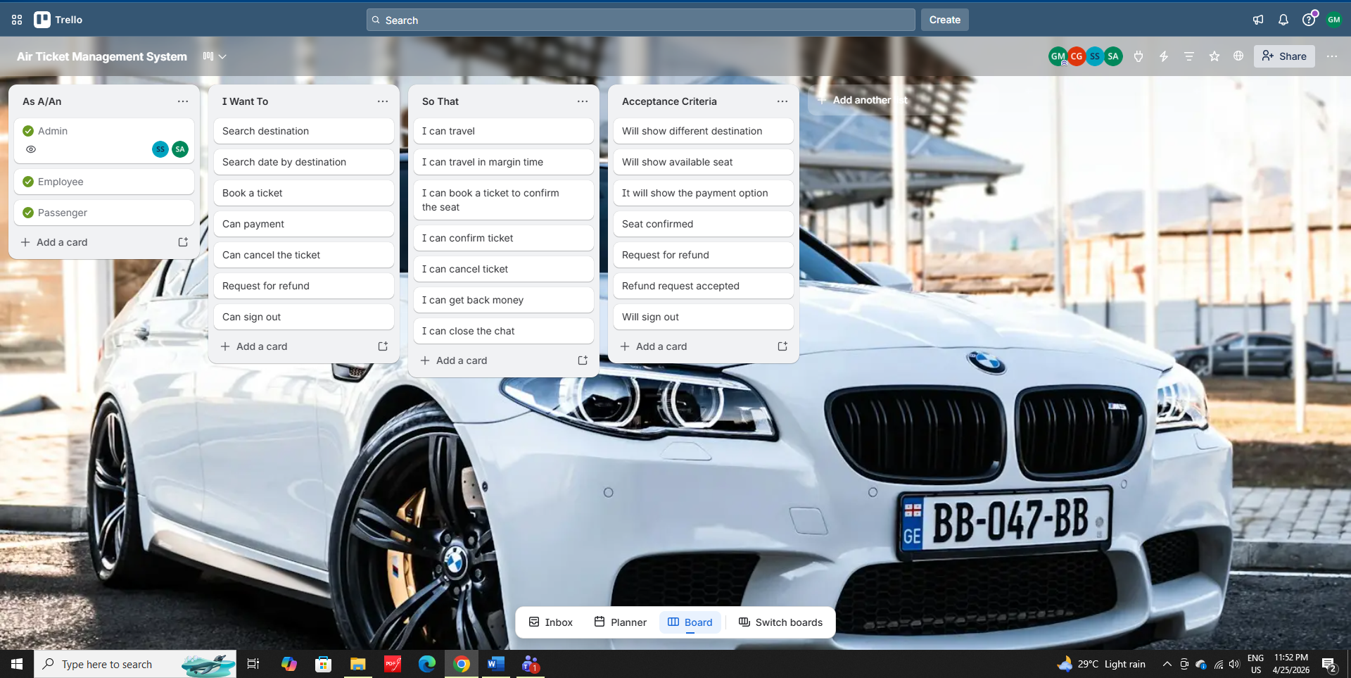
Payment:
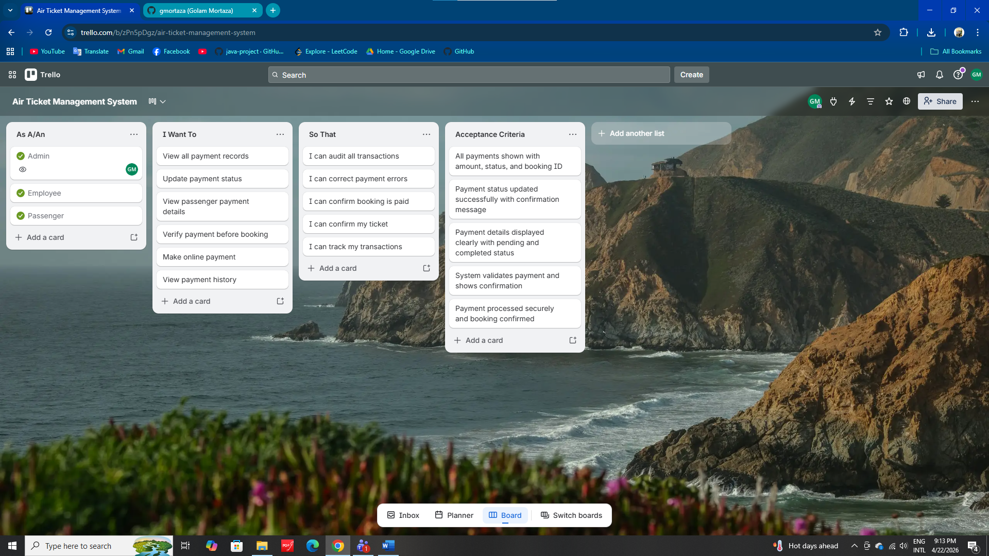
Refund:
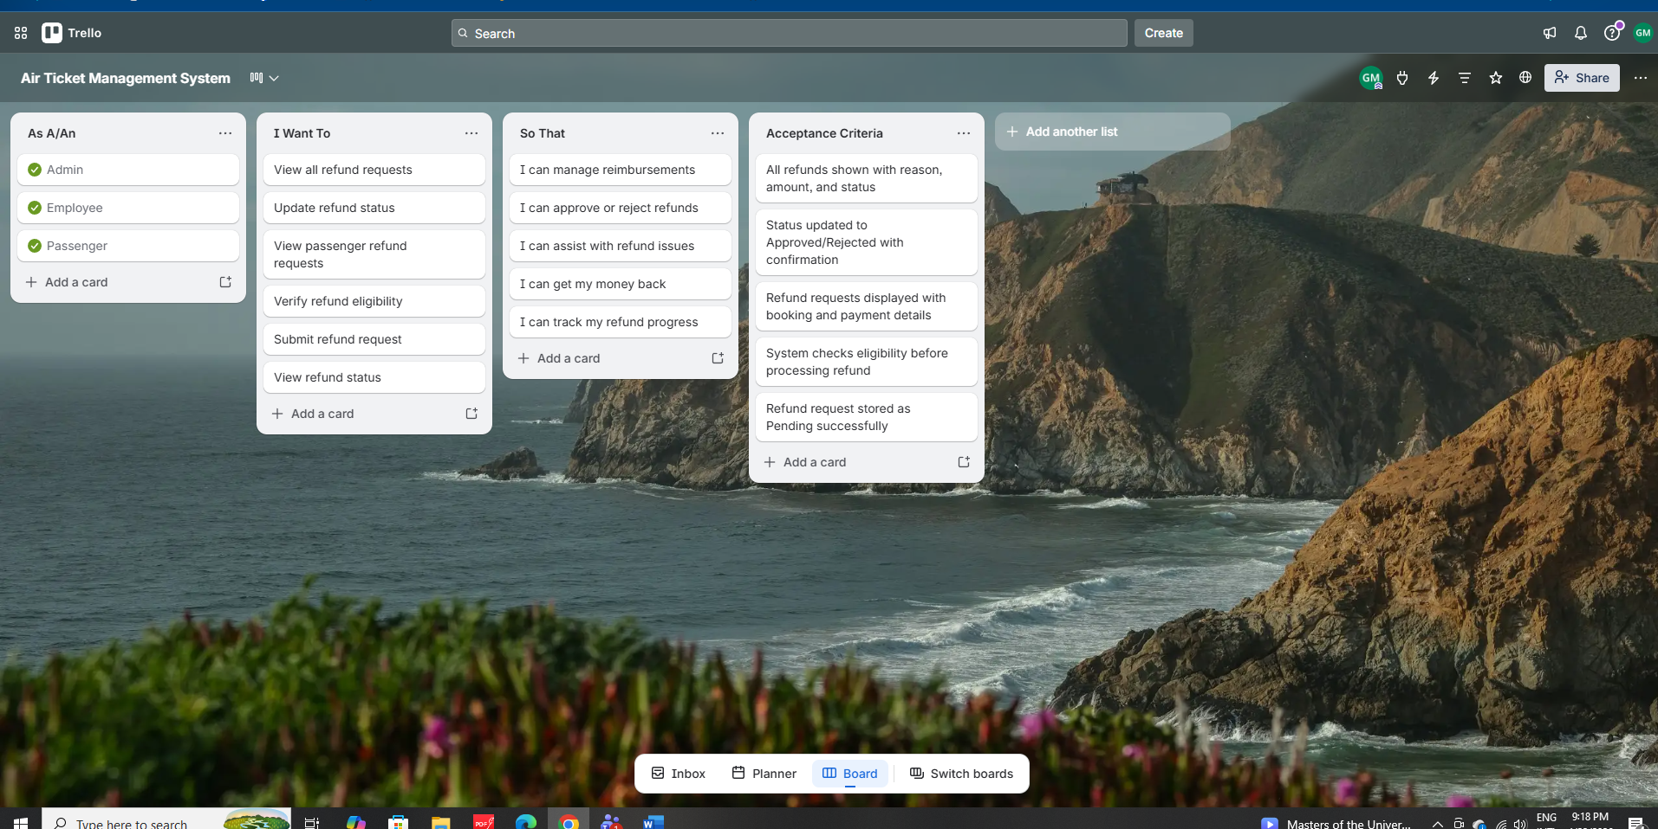

2.3 Requirements Traceability Matrix
Attribute Trade-Off Matrix (Air Ticket management System)
+ → Positive impact / supports
– → Trade-off / may reduce
(blank) → Neutral / no strong relation

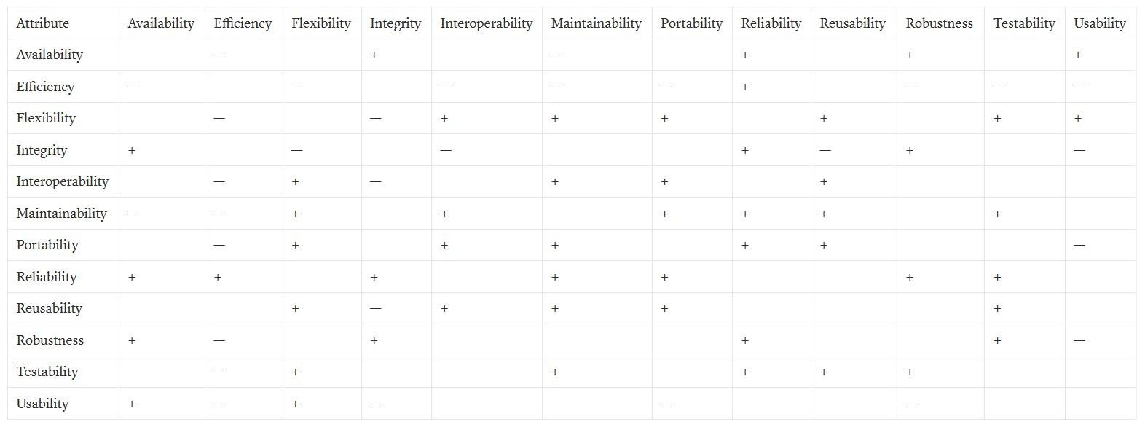
Explanation:
- Security (Integrity) vs Efficiency: Strong encryption and role-based access slightly reduce system performance.
- Flexibility vs Efficiency: Supporting future features increases system complexity and may lower efficiency.
- Usability vs Security: Additional security steps reduce simplicity but protect sensitive data.
- Maintainability & Reusability: Modular design improves long-term maintenance and system growth.
- Reliability & Availability: Real-time updates and a stable backend ensure continuous system operation.

2.3.1 Functional Requirements
User Story | Acceptance Criteria
1. As a new user, I want to register with email/phone so that I can create an account and login later | - Register with email & password  -Email verification (optional)  - Password must be secure (min 8 characters)
2. As a registered user, I want to login so that I can access the system | - Login with email/phone + password  - Forgot password option  - Login validation error messages
3. As a user, I want to update my profile so that my information is always up to date | - Edit name, phone, address  - Change password  - Upload profile picture
4. As a passenger, I want to search flights so that I can find suitable flights | - Search by origin, destination, date  - Filter by price, airline, departure time - Show flight list
5. As a passenger, I want to view flight details so that  I can choose the best flight | - Display flight duration, stops, fare - Show available seats  - Show class (Economy/Business)
6. As a passenger, I want to select seats so that I can choose preferred seat | - Seat map display  - Available/occupied seat status  - Seat selection confirmation
7. As a passenger, I want to book a ticket so that I can reserve my seat | - Enter passenger details  - Choose seat  - Confirm booking  - Booking reference number generated
8. As a passenger, I want to pay for the ticket online so that my booking is confirmed | - Payment via card/online banking  - Payment success/failure status  - Invoice generation
9. As a passenger, I want to download my ticket so that  I can show it during travel | - Ticket PDF download  - Ticket email send  - Booking details shown clearly
10. As a passenger, I want to cancel my ticket so that  I can get refund (if applicable) | - Cancellation rules apply  - Refund processing  - Cancel confirmation message
11. As a passenger, I want to reschedule my flight so that I can change my travel date | - Date change option  - Fare difference calculation  - Reschedule confirmation
12. As an admin, I want to manage flights so that I can add/update flight schedules | - Add new flight  - Edit flight details  - Delete flight  - Set seat capacity
13. As an admin, I want to manage airlines so that I can add/remove airlines | - Add airline info  - Update airline info  - Delete airline
14. As an employee, I want to book tickets on behalf of customers so that I can help customers offline | - Employee login  - Customer details entry  - Booking confirmation
15. As an admin, I want to see booking reports so that  I can analyze sales | - Daily/weekly/monthly reports  - Total sales, most booked flights  - Export report as PDF/CSV
16. As a passenger, I want to receive notifications so that I know my booking status | - Email/SMS notification  - Booking confirmation  - Flight reminder (24 hours before)
17. As a passenger, I want to rate my flight so that others can see reviews | - 1–5 rating  - Write review  - Display average rating
18. As a passenger, I want to earn points so that I can use discounts later | - Points per booking  - Redeem points for discounts
19.As a passenger, I want to make online payment so that my booking is confirmed | -Payment via card/mobile banking  - Payment success/failure status
20.As a passenger, I want to view payment history so that I can track my transactions | -All payments shown with date, amount, status  -Filter by date or booking ID  -Download payment receipt as PDF
21. As an admin, I want to manage all payments so that I can audit transactions | -View all payment records  -Update payment status  -Export payment report
22. As a passenger, I want to submit a refund request so that I can get my money back | -Cancel booking and request refund  -Refund stored as Pending  -System validates refund eligibility
23. As a passenger, I want to track my refund status so that I know when I get refunded | -Status shown as Pending/Approved/Paid  -Notification when refund is processed
24. As an admin, I want to manage refund requests so that I can process reimbursements | -View all refund requests  -Approve or reject refunds  -Update status and store transaction record

2.3.2 Non-Functional Requirements

Non-Functional Requirements

No | Name of Non-Functional Requirement | Details
1 | Performance | User requests shall be responded to by the system within 2–3 seconds under normal operating conditions.
2 | Availability | The system shall be made available 24/7 except during scheduled maintenance.
3 | Reliability | Flight and transaction data shall be ensured not to be lost due to system failures.
4 | Scalability | An increasing number of users, website traffic, and bookings shall be supported by the system without performance degradation.
5 | Security | User authentication and authorization shall be implemented to prevent unauthorized access.
6 | Data privacy | User personal information and payment data shall be stored securely and kept confidential.
7 | Usability | Ease of use shall be ensured for passengers, employees, and administrators.
8 | Accessibility | The system shall be accessible on common device such as smartphones, tablets, and desktop computers.
9 | Compatibility | The shall be compatible with modern web browsers and operating systems.
10 | Maintainability | The system shall be easy to maintain, update and enhance by developers.
11 | Response Time | The system shall be displayed flight search results within an acceptable response time.
12 | Error Handling | The system shall be displayed clear and meaningful error massages when problems occur.
13 | Backup and Recovery | The system shall be provided regular data backup and recovery mechanisms.
14 | Verification time constraint | Verification codes shall be expired after a fixed time to ensure booking data security.
15 | Consistency | The system shall be maintained constraint data across all user interfaces and databases .
16 | Portability | The system shall be deployable on different platforms with minimal changes .
17 | Load-handling | The system shall be handled multiple users accessing the system simultaneously.
18 | User satisfaction | A smooth and satisfactory user experience shall be provided through clear UI design.

3. SOFTWARE DESIGN
User Case :

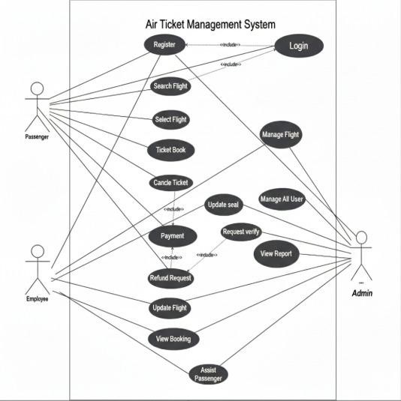

ACTIVITY DIAGRAM:
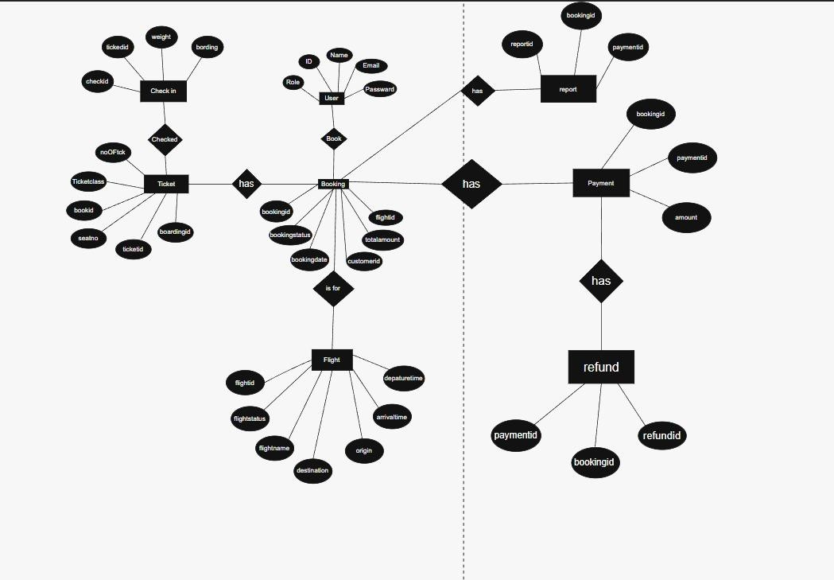

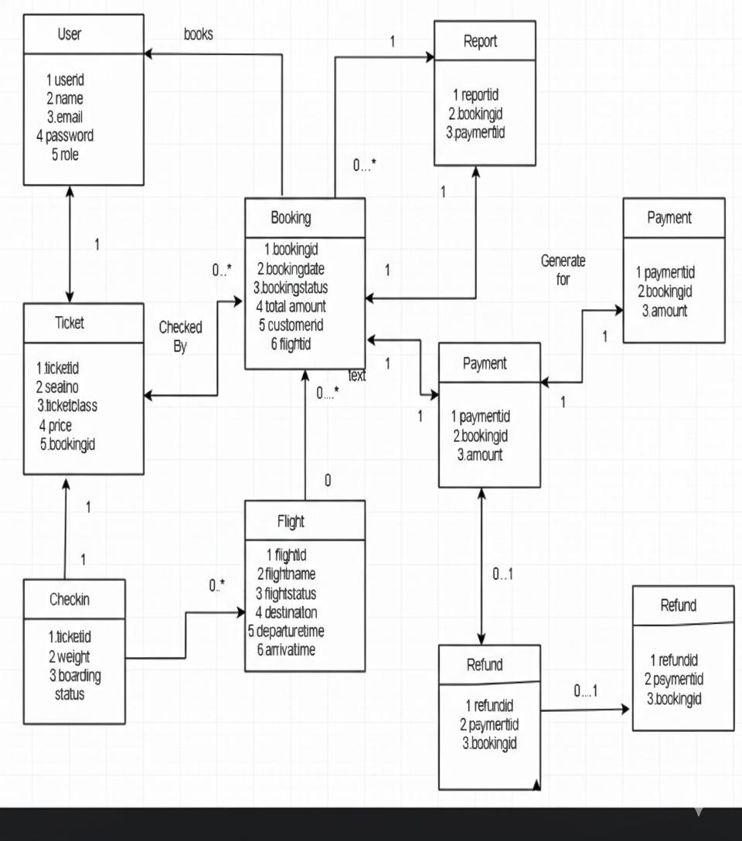
Cla
ss Diagram:

3.1.1: UI / Wireframe Design using Figma:
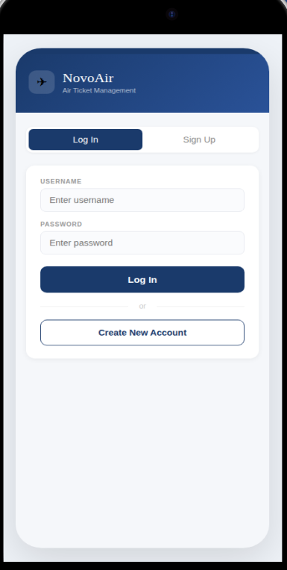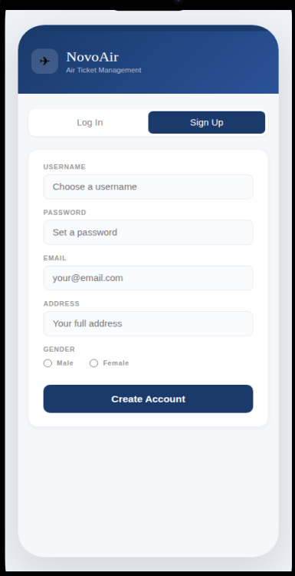
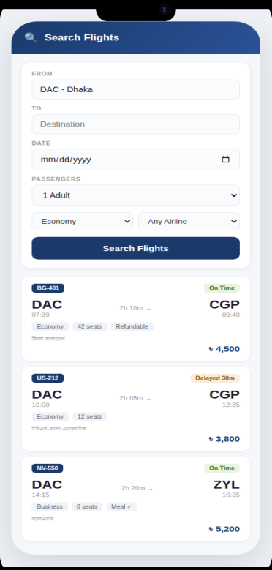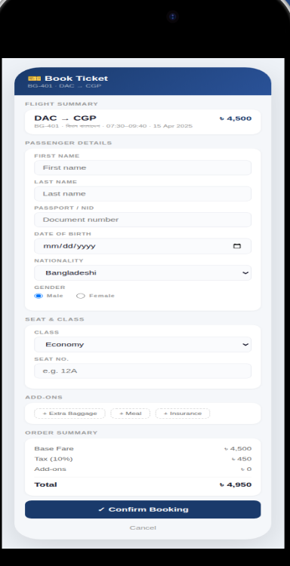
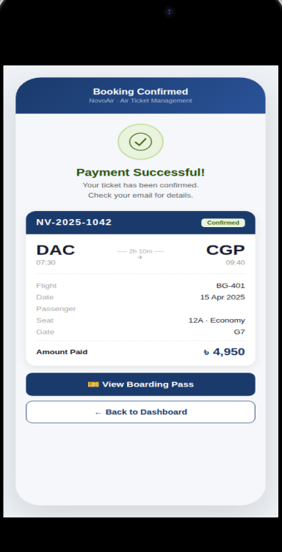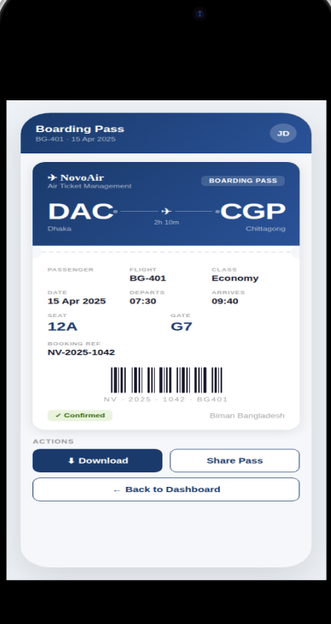
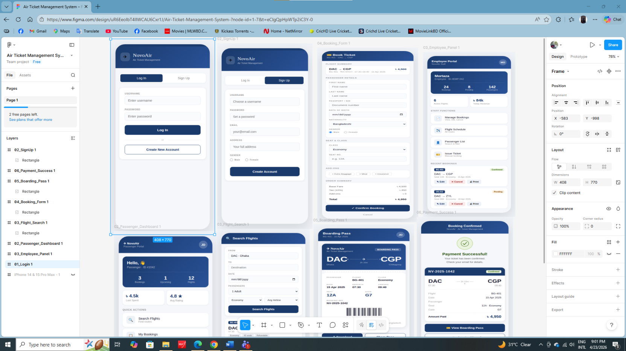

5. SOFTWARE TESTING
TEST CASE 1:
Project Name: Air Ticket Management |  |  | Test Designed by: GOLAM MORTAZA
Test Case ID: TC_ADMIN_01 |  |  | Test Designed Date: 6/05/2026
Test Priority :Medium |  |  | Test Executed by: GOLAM MORTAZA
Module Name: Flight Schedule Management |  |  | Test Execution date: 6/05/2026
Test Title: Verify admin can update flight schedule successfully
Description: Test whether admin can modify existing flight departure and arrival time
Precondition: Admin is already logged in & Flight already exists in the system
Dependencies: None
Test Steps | Test Data | Expected Results | Actual Result | Status  (Pass/Fail)
1.Go to flight management module  2.Select an  existing flight  - Click Edit  option  - Update departure time and arrival time  - Click Save | Flight No: BG202  Departure Time: 10:30 AM  Arrival Time: 11:45 AM | 1.Flight schedule updated successfully  2. Updated time reflected in flight list and database | As expected | Pass

TEST CASE 2:
Project Name: Air Ticket Management |  |  | Test Designed by: GOLAM MORTAZA
Test Case ID: TC_ADMIN_02 |  |  | Test Designed Date: 6/05/2026
Test Priority: Medium |  |  | Test Executed by: GOLAM MORTAZA
Module Name: Flight Management |  |  | Test Execution date: 6/05/2026
Test Title: Verify admin can add a new flight
Description: Check flight add functionality
Precondition: Admin is logged in
Dependencies: None
Test Steps | Test Data | Expected Results | Actual Result | Status  (Pass/Fail)
1.Go to flight Management  2.Click Add flight  3.Enter flight  details  4.Click Save | Flight No:BG101  Origin: Dhaka  Destination: Chittagong | 1.Flight added  Successfully | As expected | Pass

TEST CASE 3:
Project Name: Air Ticket Management |  |  | Test Designed by: SHAMSUL ARIFIN
Test Case ID: TC_ADMIN_03 |  |  | Test Designed Date: 6/05/2026
Test Priority: Medium |  |  | Test Executed by: SHAMSUL ARIFIN
Module Name: User Management |  |  | Test Execution date: 6/05/2026
Test Title: Verify admin can delete employee account
Description: Check user deletion process
Precondition: Admin logged in, employee exists
Dependencies: None
Test Steps | Test Data | Expected Results | Actual Result | Status  (Pass/Fail)
1.Open user list  2.Select employee  3.Click delete  4.Confirm deleteion | EmployeeID:101 | 1.Employee account deleted successfully | As expected | Pass

TEST CASE 4:
Project Name: Air Ticket Management |  |  | Test Designed by: SHAMSUL ARIFIN
Test Case ID: TC_EMP_01 |  |  | Test Designed Date: 6/05/2026
Test Priority: High |  |  | Test Executed by: SHAMSUL ARIFIN
Module Name: Booking |  |  | Test Execution date: 6/05/2026
Test Title: Verify employee can book ticket for passenger
Description: Test booking functionality
Precondition: Employee logged in
Dependences: Flight available
Test Steps | Test Data | Expected Results | Actual Result | Status  (Pass/Fail)
1.Select passenger  2.Select flight  3.Choose seat  4.Confirm booking | Seat No: A1 | 1.Booking successful  2. Seat status booked | Not as  expected | Fail

TEST CASE 5:
Project Name: Air Ticket Management |  |  | Test Designed by: MD. SHAFI MAHMMOD
Test Case ID: TC_EMP_02 |  |  | Test Designed Date: 6/05/2026
Test Priority: Medium |  |  | Test Executed by: MD. SHAFI MAHMMOD
Module Name: Booking Cancellation |  |  | Test Execution date: 6/05/2026
Test Title: Verify employee can cancel booking
Description: Test booking cancellation
Precondition: Booking exists
Dependencies: None
Test Steps | Test Data | Expected Results | Actual Result | Status  (Pass/Fail)
1.Search booking  2.Click cancels  3.Confirm cancellation | Booking ID: 205 | 1.Booking cancelled  2.Seat becomes  available | As expected | Pass

TEST CASE 6:
Project Name: Air Ticket Management |  |  | Test Designed by: MD. SHAFI MAHMMOD
Test Case ID: TC_EMP_03 |  |  | Test Designed Date: 2/05/2026
Test Priority: Medium |  |  | Test Executed by: MD. SHAFI MAHMMOD
Module Name: Payment |  |  | Test Execution date: 2/05/2026
Test Title: Verify employee can confirm payment
Description: Test payment update
Precondition: Payment pending
Dependencies: None
Test Steps | Test Data | Expected Results | Actual Result | Status  (Pass/Fail)
1.Open payment  list  2.Select pending payment  3.Update  payment status | Payment Status: Completed | 1.Payment confirmed  2.Booking confirmed | As expected | Pass

TEST CASE 7:
Project Name: Air Ticket Management |  |  | Test Designed by: SHADMAN SAKIB
Test Case ID: TC_PASS_01 |  |  | Test Designed Date: 1/05/2026
Test Priority : Low |  |  | Test Executed by: SHADMAN SAKIB
Module Name: Flight Search |  |  | Test Execution date: 1/05/2026
Test Title: Verify passenger can search flight
Description: Test flight search functionality
Precondition: Passenger logged in
Dependencies: None
Test Steps | Test Data | Expected Results | Actual Result | Status  (Pass/Fail)
1. Enter origin  2.Enter  destination  3.Click search | 1.Origin: Dhaka  2.Destination:  Sylhet | Available flights displayed | As expected | Pass

TEST CASE 8:
Project Name: Air Ticket Management |  |  | Test Designed by: SHADMAN SAKIB
Test Case ID: TC_PASS_02 |  |  | Test Designed Date: 30/04/2026
Test Priority : High |  |  | Test Executed by: SHADMAN SAKIB
Module Name: Ticket Booking |  |  | Test Execution date: 30/04/2026
Test Title: Verify passenger can book ticket
Description: Test booking process
Precondition: Flight available
Dependencies: None
Test Steps | Test Data | Expected Results | Actual Result | Status  (Pass/Fail)
1.Select flight  2.Choose seat  3.Make payment | Seat No: B2 | Ticket booked  successfully | Not as expected | Fail

TEST CASE 9:
Project Name: Air Ticket Management |  |  | Test Designed by: MD MEHEDI HASAN ALIF
Test Case ID: TC_PASS_03 |  |  | Test Designed Date: 01/05/2026
Test Priority: Medium |  |  | Test Executed by: MD MEHEDI HASAN ALIF
Module Name: Refund |  |  | Test Execution date: 07/05/2026
Test Title: Verify passenger can cancel ticket and request refund
Description: Test refund functionality
Precondition: Booking confirmed
Dependencies: Refund policy
Test Steps | Test Data | Expected Results | Actual Result | Status  (Pass/Fail)
1. Select booking  2.Click cancel  3.Request refund | Booking ID: 310 | 1.Ticket cancelled  2.Refund initiated | As expected | Pass

TEST CASE 10:
Project Name: Air Ticket Management | Test Designed by: MD MEHEDI HASAN ALIF
Test Case ID: TC_FAIL_10 | Test Designed Date: 01/05/2026
Test Priority: Medium | Test Executed by: MD MEHEDI HASAN ALIF
Module Name: Refund | Test Execution date: 07/05/2026
Test Title: Verify refund is rejected when refund window has expired
Description: Test that system blocks refund request after refund policy deadline
Precondition: Booking confirmed, refund window expired
Dependencies: Refund policy

Test Steps | Test Data | Expected Results | Actual Result | Status  (Pass/Fail)
1. Select booking  2. Click cancel  3. Request refund | Booking ID: 310 | 1. Booking selected  2. System shows refund window expired message  3. Refund request blocked | Payment timeout | Fail

Conclusion :
The Air Ticket Management System project successfully achieves its objective of automating the airline ticket booking process. The system provides a secure, efficient, and user-friendly platform for passengers, employees, and administrators. It significantly reduces manual work, minimizes errors, and improves the overall speed of ticket management operations.
The project was developed using the SCRUM software development model, which helped the team to work in iterative sprints, adapt to changes quickly, and deliver functional features continuously. Through regular sprint planning, daily stand-ups, and sprint reviews, the team maintained clear communication, better coordination, and improved productivity.
In conclusion, this system provides a reliable and scalable solution for airline ticket management. It enhances operational efficiency, ensures accurate record keeping, and offers potential for future expansion with advanced features. The successful completion of this project demonstrates the practical application of modern development methodologies and effective teamwork.

